**GHANA COMMUNICATION TECHNOLOGY UNIVERSITY**



**NAME: APPOH ABIGAIL**

**INDEX NUMBER: 2425404533**

**COURSE CODE: IT 245**

**COURSE TITE: INTRODUCTION TO WEB DEVELOPMENT**

**PROGRAMME: BSC. NETWORKING AND SYSTEM ADMINISTRATION**

**NAME OF LECTURER: MR. EBENEZER AKAGLO**

**DATE OF SUBMISSION: JANUARY, 2026**

# TABLE OF CONTENTS

1. **Chapter 1: Project Overview**  
   1.1 Introduction  
   1.2 Problem Statement  
   1.3 Project Goals
2. **Chapter 2: Planning and Information Architecture**  
   2.1 Site Map Design  
   2.2 Wireframing and User Interface Design
3. **Chapter 3: Development Environment**  
   3.1 Tool Selection  
   3.2 File Directory Structure
4. **Chapter 4: Content Construction with HTML5**  
   4.1 The Boilerplate and Meta Tags  
   4.2 Navigation and Global Header  
   4.3 Page-Specific Implementation
5. **Chapter 5: Visual Styling with CSS3**  
   5.1 The CSS Box Model and Resets  
   5.2 Layout Techniques: Flexbox and Grid  
   5.3 Typography and Branding
6. **Chapter 6: Responsive Design and Deployment**  
   6.1 Media Queries for Mobile Users  
   6.2 Version Control and Hosting
7. **Instructional Materials for Beginners**
8. **Conclusion and Recommendations**

# Chapter 1: Project Overview

### 1.1 Introduction

In today's digital age, having an online presence is essential for businesses to reach their customers effectively. TechFix Ghana is a technology repair shop located in Osu, Accra, Ghana, specializing in the repair of smartphones, laptops, tablets, and other electronic gadgets. The company required a professional website to showcase their services, display pricing information, and provide customers with an easy way to contact them.

This documentation describes the complete process of developing a multi-page static website for TechFix Ghana using HTML (Hypertext Markup Language) and CSS (Cascading Style Sheets). The project was undertaken as part of an introduction to web development course and demonstrates fundamental concepts of front-end web development.

The website development process involved several stages including planning, design, coding, testing, and documentation. Each stage was carefully executed to ensure a functional and visually appealing website that meets the client's requirements. As shown in **Figure 1.1**, the landing page provides a clear professional identity for the business.



**[Figure 1.1. The Homepage of TechFix Ghana showing the Hero section.]**

### 1.2 Problem Statement

Local businesses in Accra often lack a professional online presence. Customers seeking laptop and phone repairs need a central hub where they can view pricing, services, and contact information without visiting a physical shop first.

### 1.3 Project Goals

The primary purpose of this project was to create a professional website for TechFix Ghana that would serve as their online presence and help attract customers in the Accra area. The specific objectives of this website development project include:

* To create a visually appealing and professional website for TechFix Ghana
* To provide information about the company and its services
* To display transparent pricing for various repair services
* To showcase the workshop and successful repairs through a gallery
* To provide contact information and a contact form for customer inquiries
* To demonstrate understanding of HTML and CSS fundamentals
* To apply best practices in web development

# Chapter 2: Planning and Information Architecture

### 2.1 Site Map Design

Before coding, it was essential to map the user journey. As shown in **Figure 2.1**, the site map was created for the planned website to ensure that every page is reachable within one click from the navigation bar.

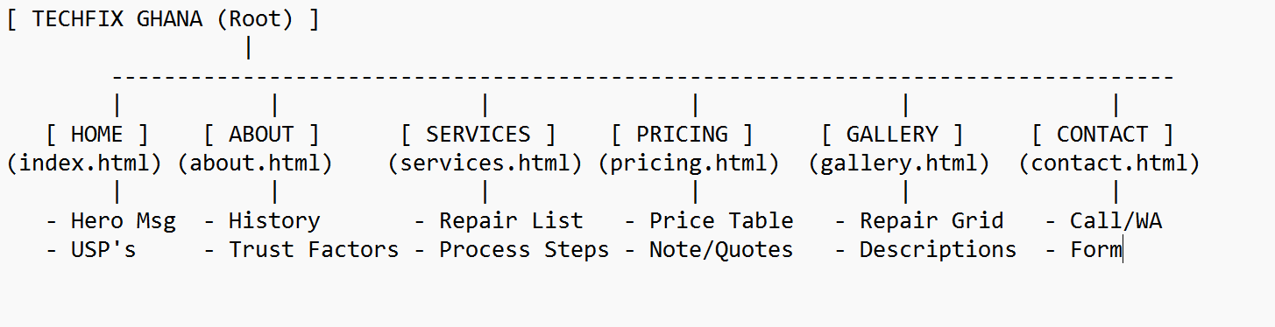

**[Figure 2.1. Site map for TechFix Ghana showing the hierarchy of pages.]**

### 2.2 Wireframing

Wireframing involved sketching the layout for each page. We decided on a "Fixed Header" approach so that users could access the menu even while scrolling through the long pricing tables. This planning stage saved significant time during the CSS development phase.

# Chapter 3: Development Environment

### 3.1 Tool Selection

For this project, Visual Studio Code (VS Code) was chosen as the primary IDE. It is the industry standard for undergraduate students due to its "Live Server" extension, which allows for real-time updates. As shown in **Figure 3.1**, the development environment was set up to view the code and the browser side-by-side.

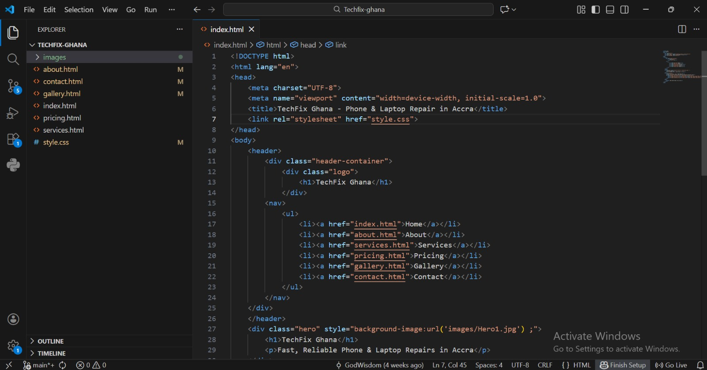

**[Figure 3.1. The VS Code workspace with index.html open.]**

### 3.2 File Directory Structure

Organization is key to web development. All images were stored in an images/ folder to keep the root directory clean. The style.css file was kept external to ensure that styling changes would reflect across all six HTML pages simultaneously.

# Chapter 4: Content Construction with HTML5

### 4.1 The Boilerplate and Meta Tags

Each page begins with the <!DOCTYPE html> declaration. We used the <meta name="viewport" content="width=device-width, initial-scale=1.0"> tag to ensure the site scales correctly on mobile phones.

### 4.2 Navigation and Global Header

The header uses a <nav> element containing an unordered list (<ul>). As shown in **Figure 4.1**, the semantic structure allows screen readers and search engines to understand the site's navigation.

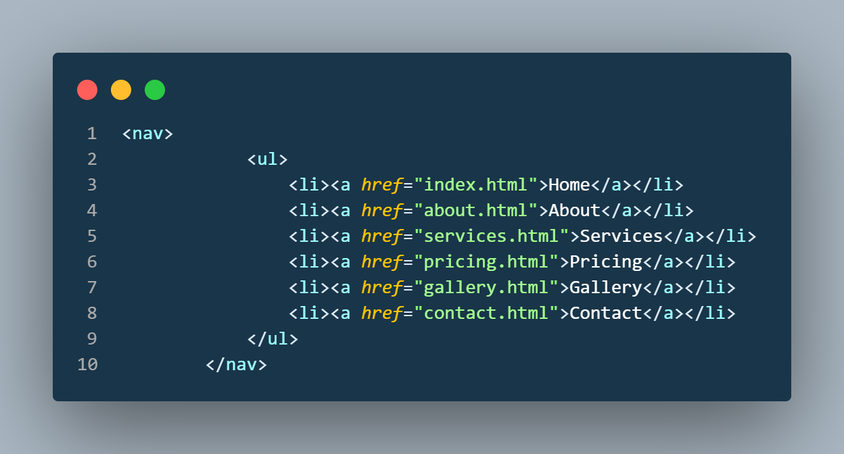

**[Figure 4.1. Code snippet of the <nav> section found in all pages.]**

### 4.3 Page-Specific Implementation

* **Pricing Page:** Utilized the <table> tag to display service costs in GH¢.
* **Contact Page:** Implemented a <form> for customer inquiries and an <a> tag with a tel: prefix for direct calling, which is vital for mobile users in Ghana.

# Chapter 5: Visual Styling with CSS3

### 5.1 The CSS Box Model and Resets

The CSS begins with a global reset to remove default browser margins. Every element is treated as a "box." As shown in **Figure 5.1**, the container class uses max-width: 1200px and margin: auto to center the content on the screen.

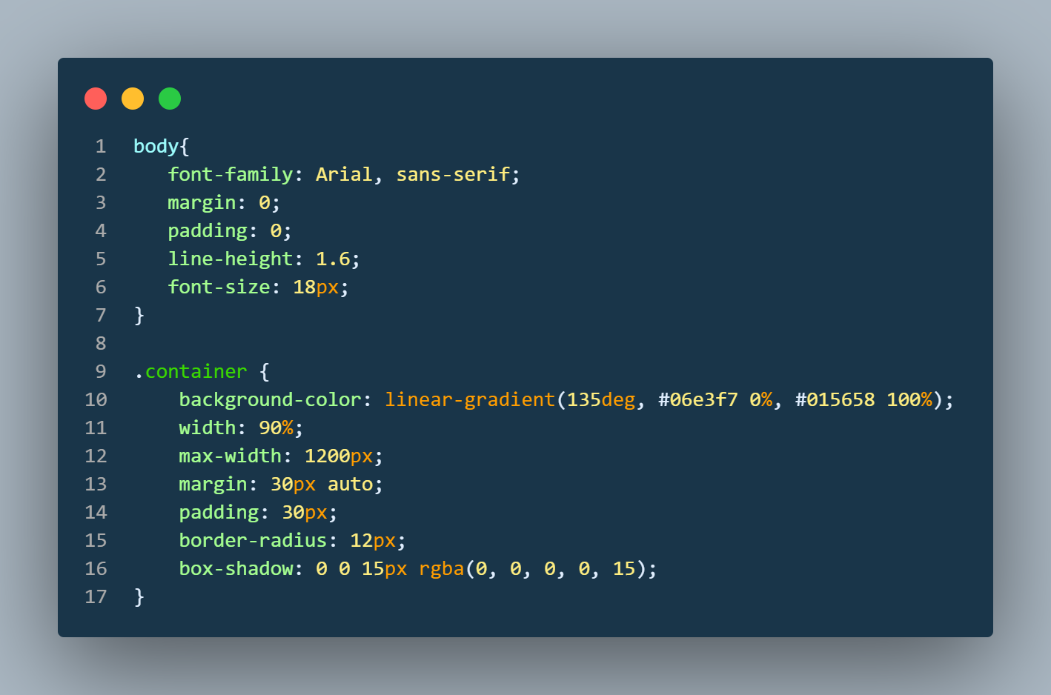

**[Figure 5.1. Illustration of the CSS Box Model used for service cards.]**

### 5.2 Layout Techniques: Flexbox and Grid

We used display: flex; for the navigation bar to distribute links evenly. For the "Gallery" page, we utilized display: grid; to create a responsive photo layout. As shown in **Figure 5.2**, the grid-template-columns property was set to repeat(auto-fit, minmax(300px, 1fr)) to allow images to wrap naturally.

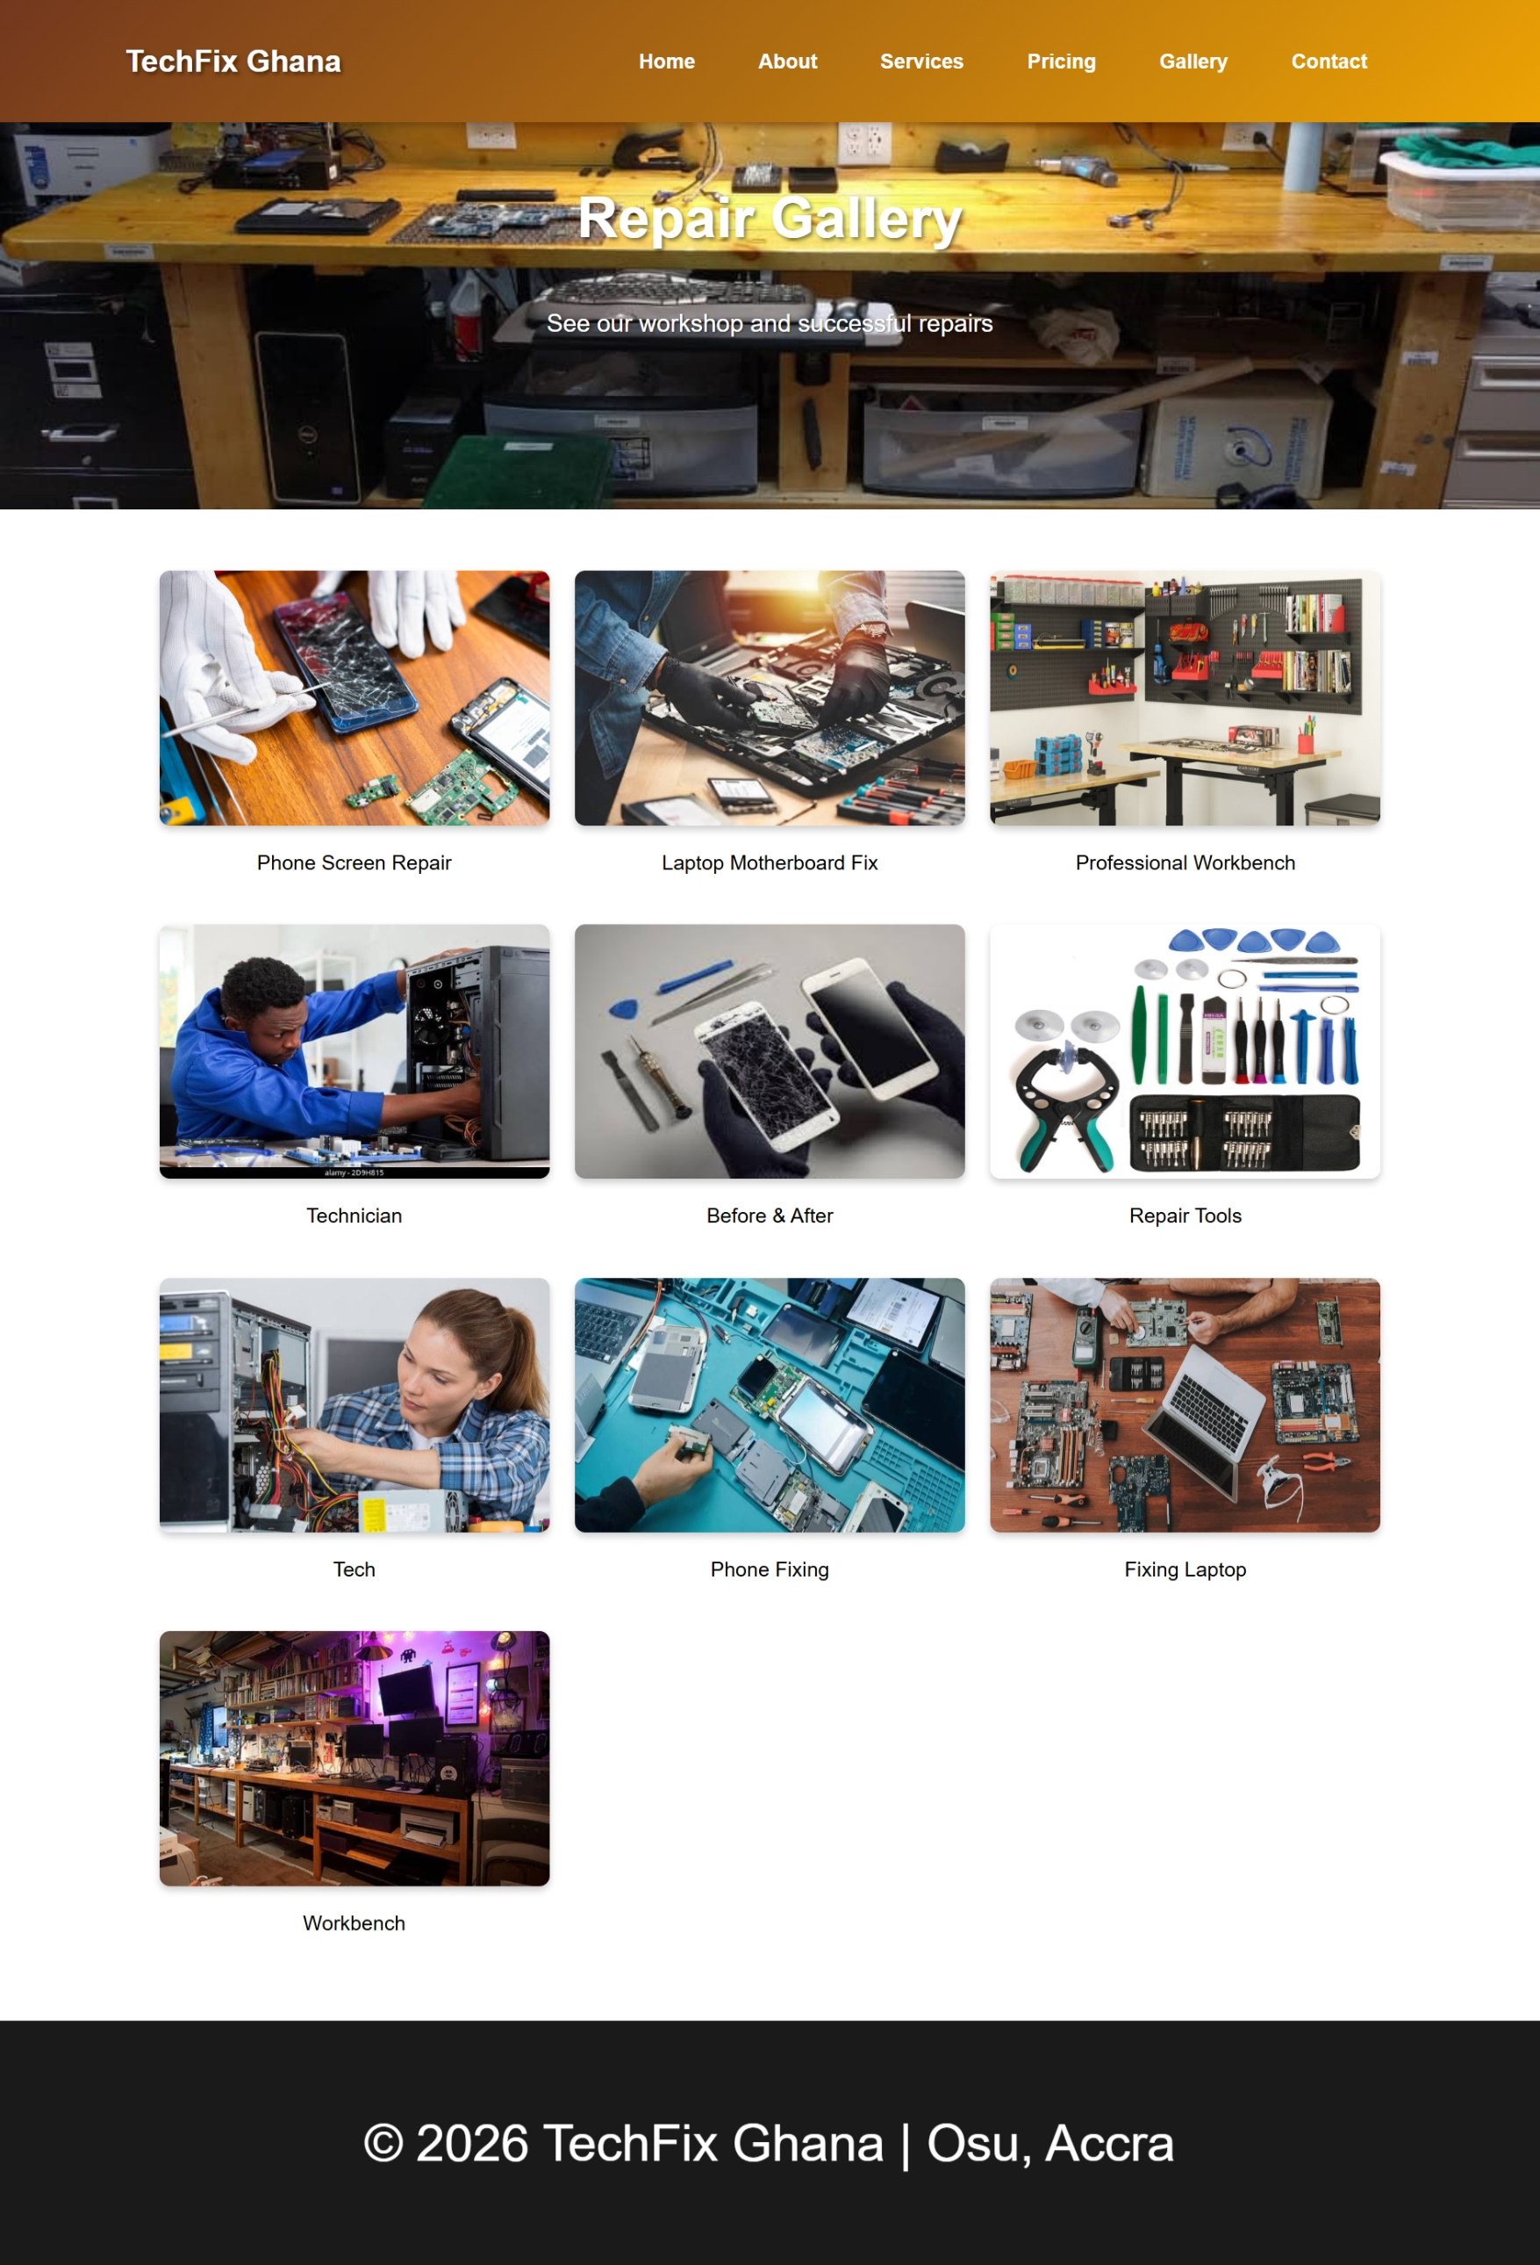

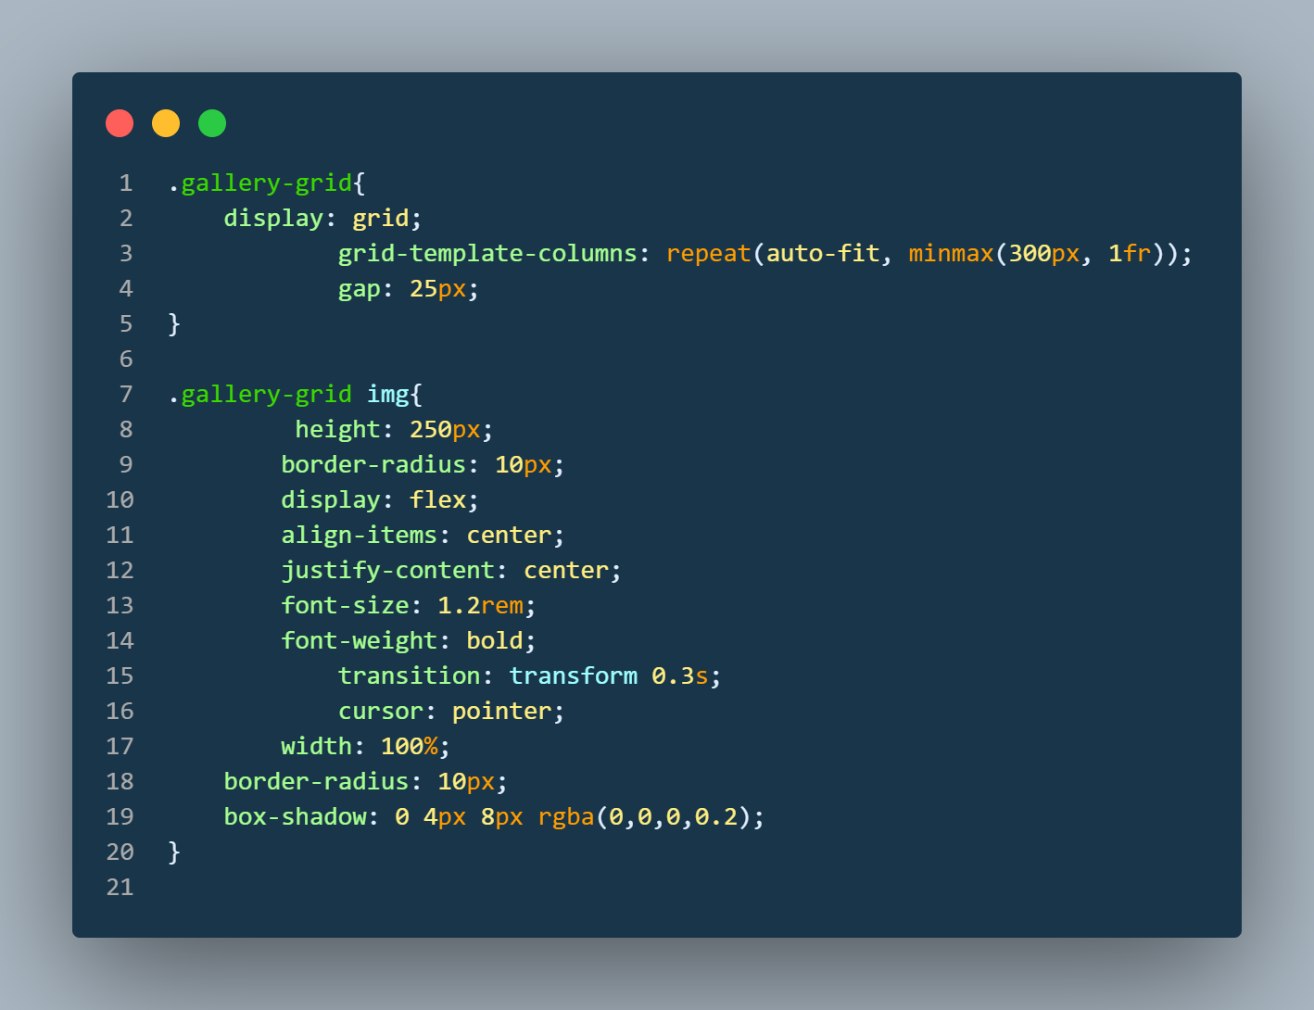

**[Figure 5.2. CSS Grid code for the Gallery page.]**

### 5.3 Typography and Branding

A linear gradient of #72371e to gold was used for the header to represent professional reliability. The font family was set to Arial, sans-serif for high readability across all devices.

# Chapter 6: Responsive Design and Deployment

### 6.1 Media Queries for Mobile Users

With high mobile penetration in Ghana, the site must work on small screens. As shown in **Figure 6.1**, media queries were used to hide the horizontal menu and stack elements vertically on screens smaller than 768px.

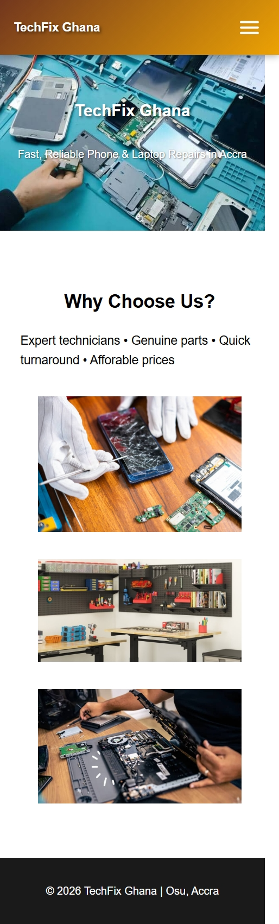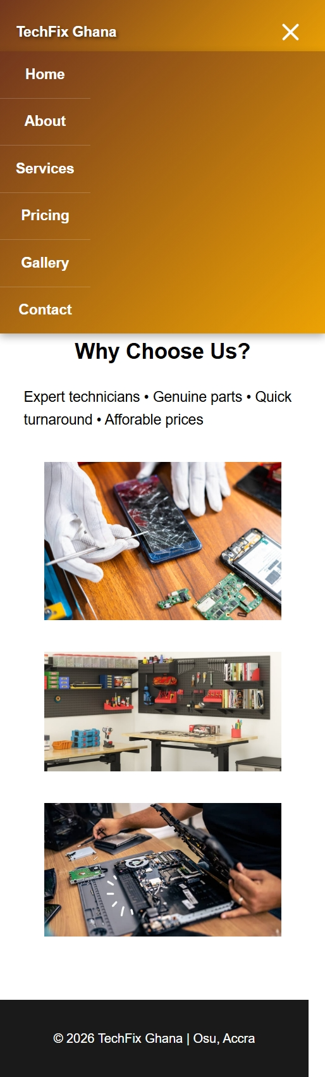

**[Figure 6.1. Mobile view of the website showing the stacked layout.]**

### 6.2 Version Control and Hosting

The project was pushed to GitHub and hosted via GitHub Pages. This process involves creating a repository and enabling the "Pages" feature in the settings. This allows the site to be accessed at [**https://fathersjoy.github.io/Techfix-ghana/**](https://fathersjoy.github.io/Techfix-ghana/)**.**

# Instructional Materials for Beginners

### Step 1: Understanding HTML tags

HTML tags are like containers. The <header> holds your logo, while the <footer> holds your copyright. Always close your tags!

### Step 2: Basic CSS Syntax

To change a color, use the selector followed by the property:

h1 {  
 color: #007bff; /* This makes headers blue */  
}

### Step 3: Ghana-Specific Tips

When building for the local market, always include a WhatsApp link:

<a href="https://wa.me/233557085469">Chat with us</a>

# Conclusion

The TechFix Ghana project successfully demonstrates that a student can build a professional-grade website using basic HTML and CSS. Future versions of the site could include JavaScript for a more interactive repair tracking system. This project serves as a solid foundation for my journey as a developer in the Ghanaian tech ecosystem.